**How to improve the writing and context of a report by using Bloom’s Taxomony**

Bloom’s taxomony is a classification of [learning objectives](http://en.wikipedia.org/wiki/Educational_aims_and_objectives) within education proposed in 1956.

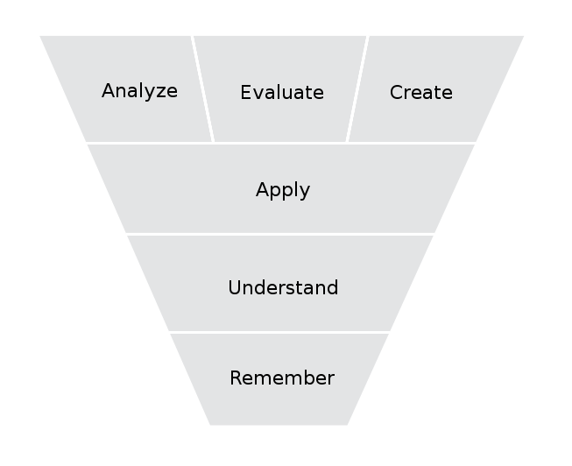

**Remember (Knowledge)**

Exhibit memory of previously learned materials by recalling facts, terms, basic concepts and answers, e.g. (facts, methodologies, principles and theories etc)

E.g.: Your report will tell

“What are the 10 basic operations of an airline”

Or “What the basic functions of an on-line shops”

**Understand (Comprehension)**

Understanding of facts and ideas by organizing, comparing, translating, interpreting, giving descriptions, and stating main ideas.

E.g.: Your report will tell

“How each of the 10 basic operations will affect the revenue of an airline”

Or “How the basic functions of an on-line shops will affect the shopping behaviour”

**Apply (Application)**

Using new knowledge. Solve problems to new situations by applying acquired knowledge, facts, techniques and rules in a different way

E.g.: Your report will tell

“An new airline will be set up in a new city, what basic operations should be included”

Or “If an on-line shop want to incrase the security of payment, what can be done”

**Analysis**

Examine and break information into parts by identifying motives or causes. Make inferences and find evidence to support generalizations

Analysis of elements, Analysis of relationships, Analysis of organizational principles

E.g.: Your report will tell

“An operation has been applied to an airline, but the operation does not perform as what it

should perform, what went wrong?”

Or

“An on-line shop has been setup, but very few customers with high volumn of purchase. Why? ”

**Synthesis**

Compile information together in a different way by combining elements in a new pattern or proposing alternative solutions

E.g. Given Lego toys of a car and an aeroplan, can you dissamble these two to make a new toy?

**Evaluation**

Present and defend opinions by making judgments about information, validity of ideas or quality of work based on a set of criteria

E.g.: Giving you three methods of cooking a food, evaluate each method and try to find the best

method and explain why.

**Creation**

Create new knowledge based on the old/known knowledge.

E.g.: After finishing my research on “music vs study results”, my research findings show that spending

20% of a student’s total study time in listening to music will have a positive effect on student’s

academic results.

<http://neurosciencenews.com/neuroscience-music-enchances-learning-neuroplasticity/>

<http://www.telegraph.co.uk/health/healthnews/10278977/Listening-to-music-is-good-for-the-heart.html>