**Information Searching Skills**

**Tasks for this week**

For your Final Year Project (Research Project), you will need a lot of information from various sources (literature) to start off and to develop your project; you must learn some information searching skills.

From the course web page, open the “A quick guide for searching and downloading past graduate projects”, go to <http://lib.cityu.edu.hk/search/X>, and then try the below (we will use Smart Phone as an example):

Searching Past Graduate Reports using key words

1. Start searching using the key words “Smart Phone” (Click <Submit> button to search)
2. Take a look of the searching result, remember the first few found report names.
3. Now you try searching again using the words “Smart Phone”, but this time, change the “Any Field” to “Title”. What can you find this time?
4. Now you try searching using the words “Mobile Phone”, and change the “Any Field” to “Title”. What can you find this time?

Download the Past Graduate Reports

1. Start searching using the key words “Smart Phone” and use the “Any Field”.
2. After search, can you find the THESIS titled as “Motion sensing techniques for mobile phone user interface design”. If you can find it, click on it.
3. Can you see the link “access full-text”? (which means you can download the whole report). If you can find it, click on it to download and open the report.
4. Once you open the report, go to find the section of “Abstract” and spend some time to read it.
5. Now try to find another report using another key words “Flight Service”.
6. Find the THESIS titled as “Assessing customer perceptions of quality of service of private flight service providers”, download and open the report.

Searching Journal using key words

A journal is an academic magazine published on a regular schedule. It contains articles written by experts in a particular field of study, based on research or analysis that the author, or authors, did.

There are two ways to read the papers/articles in a Journal. (1) Find the Journal and then read the papers inside; (2) Using keywords to find the exact papers without knowing the Journal Title.

**Method 1: Find the Journal and then read the papers inside**

1. Go to CityU Lib website.
2. Select the Tab “Journals” and then click the link “E-Journals”

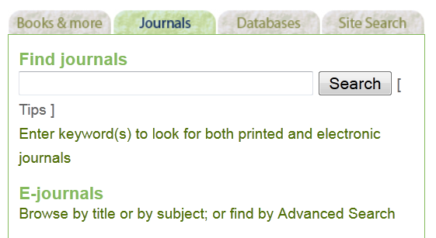

1. You will then enter the keyword of the Journal Title, e.g. Aviation. And then you will be shown a list of all Journal where their title have the word “Aviation”.

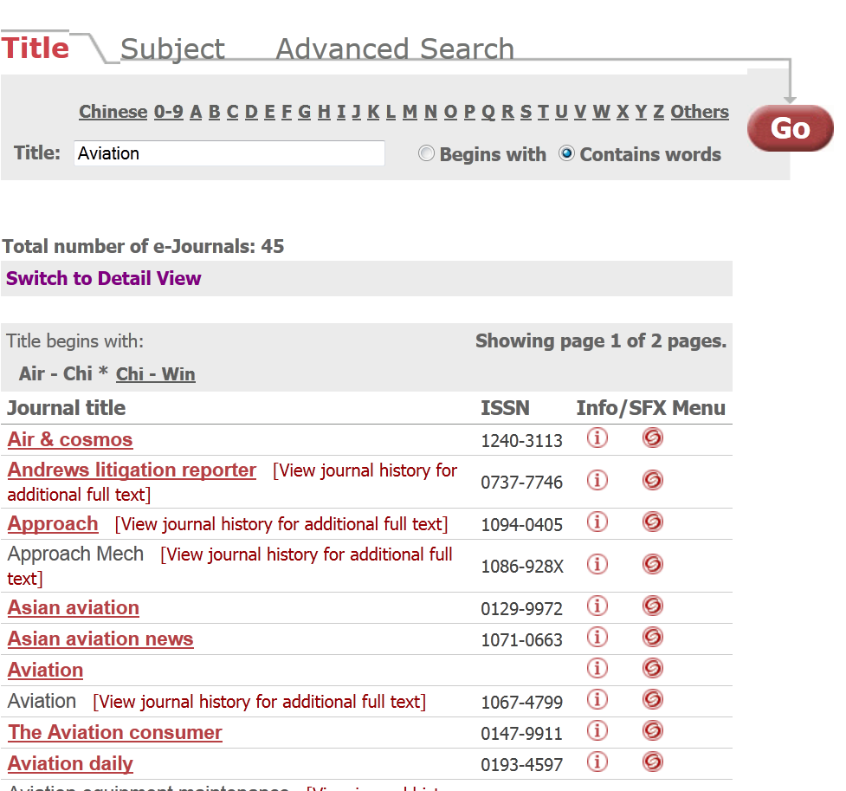

1. Now, try click on the “Asian Aviation Magazine”, all issues will be shown on the right-hand side. You click on a year and you can view the issues of that year.

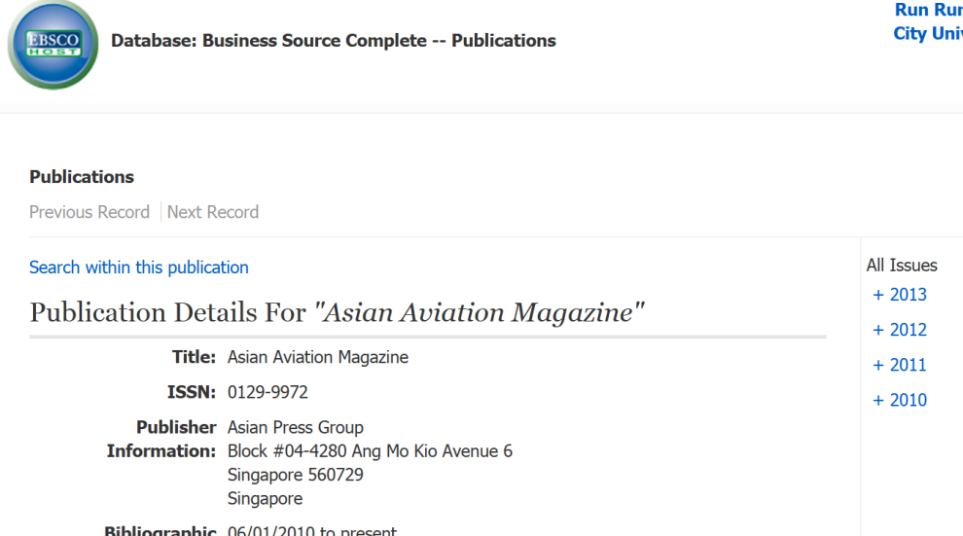

1. Now, try click on the year of “2012” and then try to open the first issue and then read the papers inside that issue.

**Method 2: Using keywords to find the exact papers without knowing the Journal Title.**

1. You need to first select a Database and then enter the keywords for search. Now go to CityU Lib. website. Select “E-Resources”, then “Database”, then “Title List”

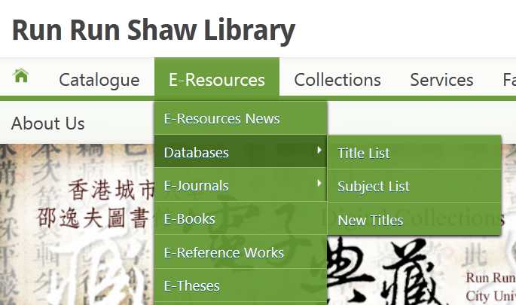

1. And then click “P” to find the database “ProQuest Databases”. And then click the “ProQuest Databases”

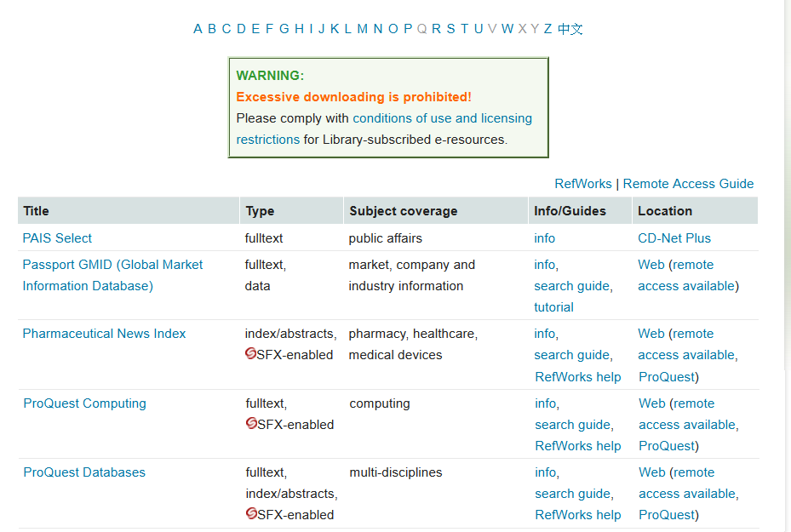

1. When you send the screen below, click the “Advanced search”



1. Now try to enter “Smart Phone”, and select the “Document title – TI” which will help you find all papers with the keywords “Smart Phone” appears in the paper title.

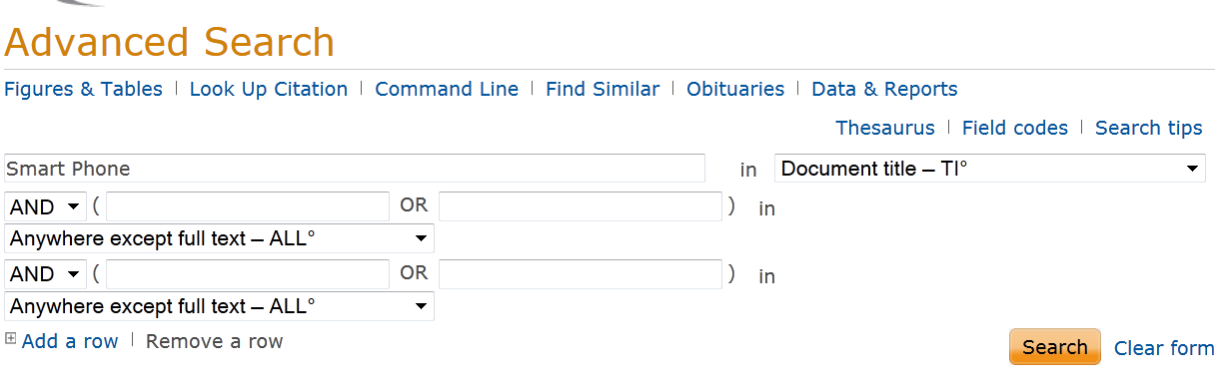

1. Now press the <Search> button and take a look of the result.
2. Try to download one or two papers to see if it works.
3. If you have time, try to use other keywords to find some papers that you may want.