Reading Paper & Finding Title
Tasks for this week

1. Find information other than CityU Lib
Last week we had found the THESIS titled as “Motion sensing techniques for mobile phone user interface design”, other than CityU Lib, can we found it somewhere else?

Let’s do a search using a keyword in “Transportation Studies”
Searching using Google / Bing
- Try to search the Google/Bing using the keywords of “airport ground access mode choice”. So what you have found?
Searching using Google and Google Scholar or Bing and Microsoft Academic Search
- Try to search Google using the keyword “access mode choice”.
- Now, open another browser and try to search Google Scholar / Microsoft Academic Search using the keyword “access mode choice” again.
- Compare the differences of (a) and (b) above, what do you found?
- So how does the Google Scholar / Microsoft Academic Search help you with your Final Year Research Project?
2. Reading the Abstract and Conclusion of a paper
- Use the searching skills you learnt last week, use the ProQuest Databases and the keywords “analysis of airport access mode choice” to papers title. You may have the result like below.
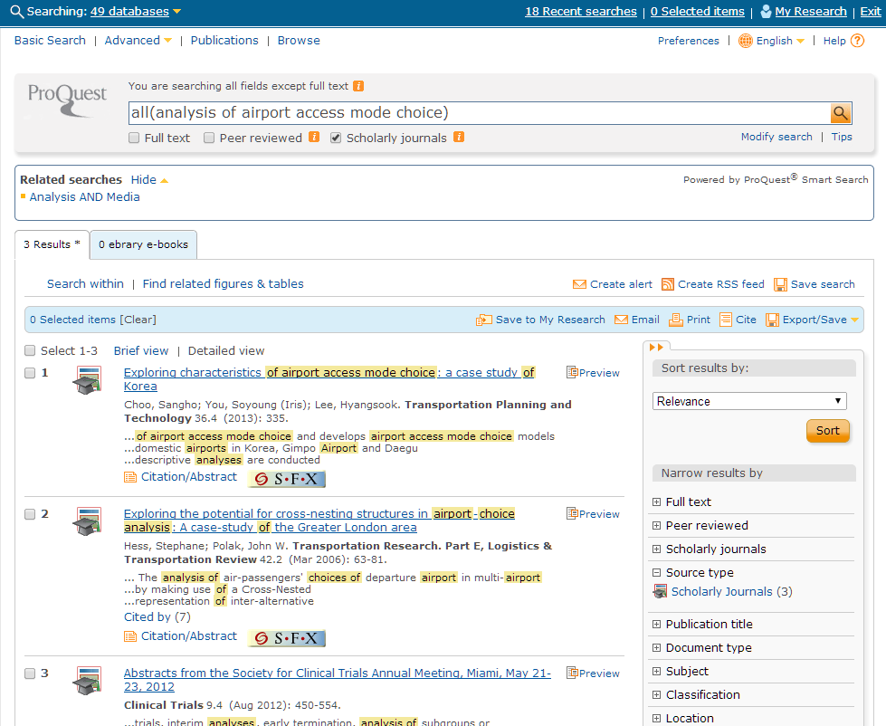
- Briefly read the Abstract of the first three papers.
- After reading, do you know what the Abstract is about? And how it is used?
- Now, try to find and download the “Full Text” of the first two papers and look at the Conclusions. Conclusion can also help you quickly understand the main idea of the paper.
3. Recording the information of the sources that are useful to you
- After you have found some information, identify from what the information source type (literature).
Examples of source include: Journal, graduate project reports, newspaper, websites, etc.
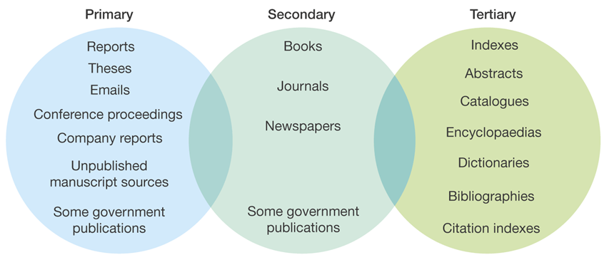

- For each useful paper/article/sources, record the following information:
Journal | Book | Chapter in a book
● Author(s) | ● Author(s) | ● Author(s)
● Year of publication | ● Year of publication | ● Year of publication
● Title of article | ● Title and subtitle of book | ● Title of chapter
● Title of journal | ● Edition | ● Author(s) of book
● Volume | ● Place of publication | ● Title and subtitle of book
● Part/issue | ● Publisher | ● Edition
● Page numbers |  | ● Place of publication
 |  | ● Publisher and page numbers

- Now find any two Journal papers and any two books related to your study, and then record the information based on the table above.

4. Study Past Final Year Project Titles
- Go to the course web page, open file “Past Project Titles”.
- You were asked to look at the past titles and find some that may interest you.
- Tutor may select some ten past titles to discuss what might the projects were about. If students found some titles interesting but do not know what the projects are about, they may ask the tutor to discuss about the project (only based on the titles).
- Students are requested to talk about their choice.
- Based on your choice of titles, you try to find some related information using the information search skills you have learnt. Should you encounter any problem, ask your tutor for help.

