***Project Air Proposal***

*A study to investigate linkage between employee satisfaction and sustainability of HongKong Airlines*

**Table of Contents**

1 Title ........................................................................................................................ 3

2 Aim .........................................................................................................................3

3 Objectives ...............................................................................................................4

3.1 Employee Loyalty................................................................................................4

3.2 Customer Loyalty ................................................................................................5

4 Background .............................................................................................................6

4.1 Service-Profit Chain............................................................................................. 7

4.2 Herzberg Motivation- Hygiene Theory............................................................... .9

4.3 Summary of background..................................................................................... 10

5 Critical review of relevant literature ...................................................................... 12

5.1. Job satisfaction among people in difference area ...............................................12

5.2 Solution to improve job satisfaction ....................................................................14

5.3 Organization Theories..........................................................................................15

5.4 Case Study: Southwest Airlines ..........................................................................16

Research Method .......................................................................................................18

Limitations.................................................................................................................19

Project Plan ................................................................................................................20

References ..................................................................................................................20

**Title:**

Sustainability of Hong Kong Airlines as a Hong Kong people's airline: analysis and recommendations from a staff satisfaction perspective of ground staff, flight attendants, pilots and maintenance staff

**Abstract:**

Hong Kong Airlines is the youngest sustaining full service passenger airline in Hong Kong. However, there are still number of factors which could challenge the sustainability of Hong Kong Airlines, and one of these being the employee satisfaction. In decades, employee satisfaction has been focused as one of the key drivers to the path of successful business and profit making, especially for the tertiary industry. There is a very famous model- the service-profit chain model which explains the relationships and interactions between the employee satisfactions and/or customer satisfactions, hence, the customer satisfaction will be one of the key to drive to profit making leading to the sustainability of the airline.

**Aim:**

To investigate and identify the linkages between employee satisfaction and the sustainability of Hong Kong airline.

Employee satisfaction towards their company has a direct relationship between its profits; growth and customer loyalty. As employee satisfaction is strongly linked to the quality of services that they provide, which then leads to customer satisfaction and hence, the customer loyalty.

Consequently, the customer satisfaction towards the service that they received by the employee of Hong Kong airline determines its sustainability as being “Hong Kong peoples’ airline”.

**Objectives:**

Within the research project, the service-profit chain would be discussed and the keys that drive employee satisfaction would also be explored. Furthermore, the literature review would be used in order to determine which elements are the most important keys to drive the employee satisfaction.

The sustainability of an airline based on 2 major elements, the customer loyalty and employee sustainability.

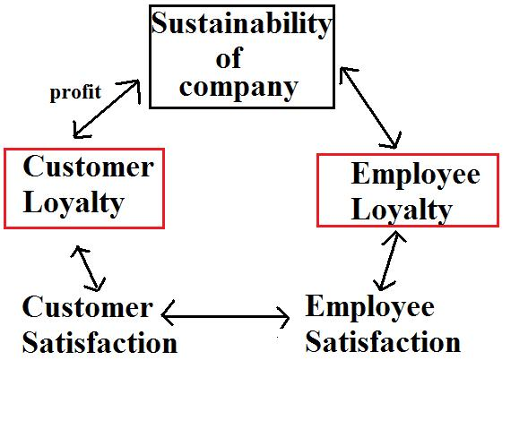

1. Employee Loyalty

Employees are a vital resource for nearly all organizations, especially since they represent a significant investment in terms of locating, recruiting, and training let alone salaries, healthcare plans, bonuses, etc.

Replacement can cost a company anywhere from 35% to 50% of an hourly worker’s salary. For a technical or professional worker, the cost can go as high as 125% of that worker’s salary.

Therefore, employee satisfaction will be the indicator for employee loyalty, and is one of the main factors we will be focusing at in this research. It could be done in both quantitative and qualitative way in forms of interviews and survey respectively. Research will be carried out with HongKong Airlines employees in a randomly and irrespective manner, investigating the motivators and the hygiene factors that affect might affect the retention (or turn-over) rate within the company.

1. Customer Loyalty

The term customer loyalty is used to describe the behaviour of repeat customers, as well as those that offer good ratings, reviews, or testimonials. Some customers do a particular company a great service by offering favourable word of mouth publicity regarding a product, telling friends and family, thus adding them to the number of loyal customers. However, customer loyalty includes much more. It is a process, a program, or a group of programs geared toward keeping a client happy so he or she will provide more business. By increasing the customer loyalty, it would definitely increase the profit and hence the sustainability of the company.

Investigating customer satisfaction is the qualitative way to look for customer loyalty. It would be done in form of a qualitative survey, ranking how satisfy they are with the service that they received in terms of quality of staff (i.e. greetings, obvious facial expression etc.) and on time performance, this set of data will then be used for doing a statistical comparison with the employee satisfaction.

Research would be carried out in form of surveys and interviews with current employees of Hong Kong Airlines. Further to discuss the dissatisfaction and/or challenges that they might have in all aspect, hence to find out possible ways to sustain the Hong Kong Airlines as a Hong Kong people’s airline from the staff’s satisfaction perspective.

**Background:**

In this economical world, the most important key driver to sustain a business or a firm is the “Profit Making” or the potential of “Profit Making”. However, especially for the service industry, the potential of profit making will mainly depends on customer’s value and customer’s satisfaction. Whereby these important factors are based solely on the “result” of the service they received, by means the quality of the processes for delivering results, including the attitude of those in direct contact with customer, is important. Furthermore, the performance by the frontline operators that involve with that particular result might be also affected by their own satisfaction towards company. Hence, the interaction between the employee satisfaction and customer satisfaction has a strong correlation in the airline industry, and thus, the Service-Profit Chain could explain their relationships.

In addition, critical incidence strongly affects company reputation and employee/customer satisfaction. The incidence might accelerate the exposure of the management problem within the company. It is important to be able to look for the reasons that lead to that problem and be able to find out solution to execute them.

Typhoon Vincente that strike Hong Kong on the 24th July, 2012 created a big chaos for Hong Kong aviation industry, and that was the most recent incident that exposed the tension between company-employees-customers. According to South China Morning Post (cited on 30th July, 2012):

*Hong Kong Airlines was still struggling to clear a backlog of passengers at Chek Lap Kok airport yesterday following last week's flight disruption because of storms*

*Some ground crew members complained they had been working non-stop for more than24 hours before being able to go home, while on Saturday about 20 staff members took sick leave in what was seen as a protest against the management's manpower arrangements.*

It has clearly shown the company policies or management would directly affect employee dissatisfaction. Which, lead to problems facing company itself (e.g. might lead to strike), the final result would be rupturing company’s reputation and decreasing customer dissatisfaction.

1. Service-Profit Chain:

In the late 90s, Heskett, Sasser & Schlesinger had found the business model based on their research on those companies’ behaviour and their profitability. They discovered that there are strong relationships in between profit, revenue growth, customer loyalty and/or satisfaction, service value that delivered to the customers, staffs’ capability, satisfaction, loyalty and/or productivity and also the leadership driving behind. (Heskett & Sasser & Schlesinger, 1997)

Their relationship is shown as a graph as follow:

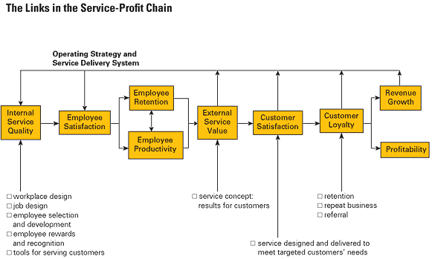

Service-Profit Chain (Heskett& Sasser & Schlesinger, 1997)

As shown above, the Profit and growth are primarily stimulated by customer loyalty. Loyalty is a straight result of customer satisfaction. Satisfaction is mainly influenced by the customers’ perceived value of services from the frontline service providers. This Value is created by employees including the frontline service operators’ satisfaction, loyalty, and production. Employee satisfaction, in turn, results primarily from high-quality support services and policies that enable employees to deliver results to customers. The service-profit chain is also defined by a special kind of leadership that emphasizes the importance of each employee and customer. (Heskett & Sasser & Schlesinger, 1997)

As explained from above, it is the frontline service providers who directly deliver the service value to drive the customer satisfaction and loyalty and thus the continuous profitability, and the employee satisfaction is the key driving the performance of these frontline service providers. Within the model, the employee satisfaction is explained to be driven by the “internal quality”. This “internal quality” is the measure of the employee’s motivation and can be related to many factors such as workplace design, job design, employee selection, training and development, rewards and recognition, and tools for serving customers. The employee satisfaction can be enhanced by increasing the internal quality, and therefore in turn influences employee productivity, turnover and retention. (Holloway, 2002)

For the Employee’s motivation, it can be further explained and supported by the other theory- Herzberg’s Motivation-Hygiene Theory also known as two factor theory.

1. Herzberg’s Motivation-Hygiene Theory:

Within the theory, Frederick Herzberg had found that there were two types of factors which can directly cause the satisfaction or dissatisfaction in an employee’s work environment. He also found that factors that cause job satisfaction are different from the factors causing job dissatisfaction. In other words, these two types of factors cannot be treated as opposites of one another. The opposite of satisfaction is rather no satisfaction, and the opposite of dissatisfaction is the “No dissatisfaction”. Therefore, eliminating the dissatisfaction factors cannot create satisfaction; on the other hand, eliminating the satisfaction factor would not produce and dissatisfaction. For the causes of the satisfaction, he concluded them as the motivators, and for the causes of the dissatisfaction, he concluded them as the Hygiene factors. They can be concluded as the following table:

|  |  |
| --- | --- |
| Motivators | Hygiene Factors |
| * Achievement * Recognition * Work itself * Responsibility * Advancement * Growth | * Company policy * Supervision * Relationship with Boss * Work Condition * Salary * Relationship with Peers |

(Herzberg, 1997)

Thus, the hygiene factors must be present in order to diminish the dissatisfactions. On the other hand, motivators are required to augment the motivation of the employees leading to higher satisfaction towards their company. Hygiene factors and motivator are two separate factors that do not interfere with each other. For example, manager assign more challenging works (more responsibility) to an employee because he knew that he is capable to handle more difficult jobs (recognition from the manager to the employee-thus motivate the employee).

1. Summary of Background:

Heskett (1995) has this to say about the linkage between employee loyalty and customer loyalty.

*Market share quality often results directly from efforts to build the satisfaction and loyalty of service workers who are in direct contact with customers. Employee satisfaction results from initiatives to match attitudes and skills with jobs, train and recognise people, rethink work, and provide technological support to increase the capability to deliver result to customers. It clearly requires attention to both operating and human resource management issues, once again a bridging of functions.*

As per discussion above, the sustainability is driven by the customer satisfaction and loyalty which is driven by the frontline operators’ performed value; the value is then driven by the employee satisfaction which is initially based on the elements of motivation. These elements can be divided into Motivators and Hygiene Factors. Therefore, this research will be conducted in regards to these factors by interviewing with the frontline service providers. In this case within the airline company, the targeted employees would be pilots, air hosts, ground crew (customer service officers) and the maintenance staffs. However, the elements of motivation, and how these elements can be related to the sustainability of the business will have to be developed further within the literature review.

**Critical Review of relevant literature**

Several studies have shown the positive correlations between the employee satisfaction and customer satisfaction. ([[Bernhardt et al., 2000]](http://www.sciencedirect.com/science/article/pii/S0278431908000790#bib4), [[Harter et al., 2002]](http://www.sciencedirect.com/science/article/pii/S0278431908000790#bib15), [[Koys, 2003]](http://www.sciencedirect.com/science/article/pii/S0278431908000790#bib23), [[Tornow and Wiley, 1991]](http://www.sciencedirect.com/science/article/pii/S0278431908000790#bib36) and [[Wangenheim et al., 2007]](http://www.sciencedirect.com/science/article/pii/S0278431908000790#bib37)) Based on these assumptions, employee satisfaction has been one of the most important factors to focus during the researches, and had become a critical issue for the past 2 decades.

Apart from the “Two Factor theory”, there are many more theories which also explain the employee’s motivation and attitude. And certainly, in different areas according to the regional culture, only some particular theories may be supported by the people in specific regions, therefore, there are still some contradictions among them. In other words, different people may define job satisfaction differently. In addition, there are lots of studies which also show how the employee satisfaction relates to the successful business result which contribute to the sustainability of the firm.

1. Job Satisfaction among People in Different Area:

A survey had been done in Malaysia according to the flight attendant job satisfaction. It was found that the emotional exhaustion and personal accomplishment can have a very strong effect on the job satisfaction. According to the study, the emotional exhaustion can be caused by lack of resources with increased performance expectation at the same time. The personal accomplishment may count on feelings of competence and accomplished job duty achievement. In addition within the study, the over workload may be perceived as a result of the good performance if the company is in crisis. (Ng & Sambasivan & Zubaidah , 2011)

However, a different survey had been done in Turkey according to job satisfaction of employees. The result is quite different. Salaries, working condition, promotion and progression are the most important elements which could directly affect the staffs’ motivation in order to determine whether they are satisfied with their job or not. The authors also indicated that getting a fair paid is a very important element to the job satisfaction, if the employee’s job satisfaction was too low, they might resign as a result. (Orman, Unakitan & Selen, 2011)

Some also argue that the job itself can influence job satisfaction. A research had been done in Taiwan within the information technology area. The research has revealed that the job characteristic has a positive relationship with the job satisfaction, and the job with feedback, professionalism and autonomy can upgrade the satisfaction level, especially the job feedback which is the top one reason to increase the employee satisfaction. The reason behind them is the employee wants to enhance their self-actualization and social satisfaction. (Chen, 2008)

There was another study which also showed that the job satisfaction was greatly influenced by job motivation, and job motivation was affected by both the instrumentality and intrinsic valence. The instrumentality is the expected reward of employee which they receive after doing their job well. The valence is the actual reward which motivates them to work. The intrinsic instrumentality can give the employee a sense of accomplishment and feeling of Excellency when they perform well. The intrinsic valence can motivate them to fully use their ability and take more responsibility in the company. Both enhance the employee motivation towards their satisfaction. However, it also shows that the satisfaction can also be affected by the extrinsic valence, such as if their expected extrinsic reward cannot be received with their good job performance, then their motivation and hence their satisfaction would also be lowered. (Chiang & Jang, 2008)

As being discussed from the above, different employee may need different elements of motivation to contribute to job satisfaction according to the region and culture. Therefore a survey must be conducted through the company in order to find out the result.

1. Solutions to improve job satisfaction:

If the elements of job satisfaction are known, then the generation of solution would be easy to be established. Despite all these, there are some other methods which can be used for improving employee satisfaction.

There was a case-study being done in 2005 on maintenance of employee motivation in the U.S. It discovered that motivation can be enhanced with respectful contact with beneficiaries, and this can be done without changing the properties of the assigned tasks that comprise work. Such as within a organization that a group of backroom accountant who never meet their client, if a manager can introduce her to the client to show how she did a good job to these clients and have a great impact on them, then her motivation can be kept highly. (Grant & Campbell & Chen & Cottone & Lapedis & Lee, 2007)

1. Organization Theories:  
     
   Organization theories (e.g., Schneider and Goldstein, 1995) suggest that all employee groups contribute to the organizational climate, which in turn affects employee satisfaction, customer orientation and customer satisfaction. Wangerheim (Wangerheim et al, 2007) has therefore done a research based on a diverse group of employee, in order to find out whether or not there is a different level of satisfaction within the employee-customer link. In other words, whether or not this link is present in a group of employee that only has little or no direct interaction with customer? Or in comparison, is the link stronger for employee group that have more intensive customer contact?

There are some theories could be applied into Wangerheims’ research, the “Emotional contagion” and the “Attraction-Selection model”, however they contradicts with each other:

“Emotional Contagion” was suggested by Homburg and Stock at 2004, the level of experienced job stressed is negatively correlated to employee’s satisfaction. Thus, a highly dissatisfied employee will (unconsciously) exhibit a high level of emotional tension expressed through facial expression, vocalization, and other observable behaviour.

“Attraction-Selection model” states the people within same organization become more similar in their disposition, and consequently, more homogenous in attitude (Schneider and Goldstein, 1995), suggesting all employees are under the same working climate, in order to achieve a common goal.

Each theory has got different influence to customers. In combination, as this profit service chain is dynamically affecting one and other in a form like :

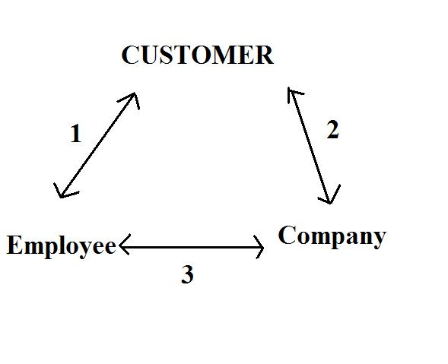

For emotional contagion, it starts off directly affecting the linkage between employees-customer (1), and hence it affects the linkage between customer-company (2). In order to prevent disappointment created in link 1, we will need to investigate into the problems that each job type they dissatisfy about (i.e. the hygiene factors).

Whereas for the attraction-selection model, the homogenized attitude within employees lead to a “common goal” inside the company. This is exactly the linkage between company-employee (3). Southwest Airline is the best example in introducing the importance of this link. They proven by strengthening the company-employee relationship will definitely improve link (1), and hence increase customer loyalty.

1. Case Study: Southwest Airline (SW)

South West Airline has an open door policy, which enable them to build and sustain relationship characterized by shared goals, shared knowledge and mutual respect. SW truly values both the quality of the relationships and also long term relationship, which are the very important factors in order to lower the turn-over rate and increasing the productivity among the employees and therefore improve the link (3).

From a Southwest pilot’s perspective:

When you come in [to the gate] and see everybody there ready to go to work, it makes you feel great.

It shows the importance of the satisfaction that purely created by successful teamwork within the whole organization. They succeeded because of the outstanding leadership under Herb Kelleher, the CEO and president of Southwest Airline, who believes listening to employees and caring about problems are very essential to maintain the relationship between the company and employees.

However, in Hong Kong, the media usually overrides when come into employee and/or customer dissatisfaction, which most of the time are also exaggerated, and hence, tend to worsen or break the linkage in all directions.

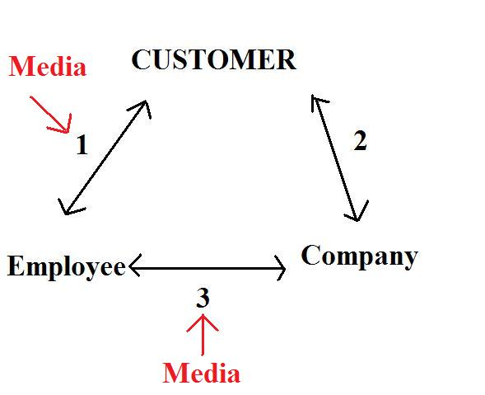

In order to avoid media interfering upon those linkages, education and leadership of employees play an important role. First of all, homogenization of employee will be useful, and secondly, creating a channel that listen to employee and take real action encountered to the problems will also be very important.

The Chicago ramp manager confirmed this approach:

*We work real hard to remove that barrier so that agents can come in and talk to a supervisor or manager. There’s an open door policy so when employees have a problem, they know we can work on it together. It’s a totally different environment here. We sit and listen. When that person walks away, he’ll have self-esteem.*

*I learned this when I came to work the ramp [here]. Even when you did something wrong, they’ll ask what happened. They’ll tell you what you can do so it doesn’t happen again. You walk away so upbeat that you work even harder.*

**Research Method**

The research would be carried out to fulfill the objectives. To investigate whether there is a linkage between employee satisfaction and sustainability/growth of HongKong Airlines.

Data for this study will be collected from the employees, customers and managers of HongKong Airlines. Which 15-20% of employees each job type are selected randomly to increase the reliability of this research.

A questionnaire would be used to establish the view and comment via interview, and a survey for ranking in different aspect for satisfaction/dissatisfaction, including work environment, salary, company policy, mutual respect, etc.

The qualitative result of the survey would then use for establishing a set of statistical data, the probability of each linkage will then be calculated and to be analyzed.

1. Create a focus group

The focus group is an interview style designed for small groups of unrelated individuals, formed by an investigator and led in a group discussion on some particular topic or topics. (Barbour, 2008; Schutt, 2003)

For efficiency purpose, there would be 4-5 interviewees per interview. Focus group interviews explicitly use group interactions as part of the data-gathering method. (Edmunds, 2000)

1. Group Interview

Group interview would be carried out twice with 2 different groups of interviewees per set, i.e, do twice with 2 groups of different employees, and twice with 2 groups of different customers.

Open-ended questions will be asked, and the advantage for a group interview is to be able to arouse the interviewees to bring up ideas and develop in all directions.

Explore and setting the parameters

The content during the interview could be used for setting the parameters for the questionnaire on:

-Satisfaction

-Airline sustainability

1. Tailoring the questionnaire for employees and customer

4) Deliver of qualitative questionnaire

Questionnaires for employees will be distributed among employee randomly within the company; the customers for the sample will be selected randomly within a controlled environment (e.g. on board, at the gate or at the baggage area)

5) Analysis of result

The statistical result will be generated by SPSS.

**Limitations**

According to prior research done by (Gilbert and Wong, 2003), the respond rate of questionnaire in Hong Kong International Airport is about 34%. In this research, sample size for customer required to be above 200 in order to achieve reliable result. Therefore, in combining with the respond rate of 34%, at least 589 questionnaires should be done for the customer set data.

For the employee set, the sample size should also be above 200. Questionnaire would be delivered randomly within HongKong Airlines. However, statistically 15-20% of the employees are needed to represent the HongKong Airlines. Thus, if the 15-20% of the employee count is below 200, a full scale (100%) survey would be required.

**Project Plan**



**Reference**

Barbour, R. (2008). *Doing Focus Groups.* Thousand Oasks, CA:Sage

Bernhardt, K.L, Donthu, N, Kennett, P.A, (2000) A longitudinal analysis of satisfaction and profitability, Journal of Business Research, **47**, 161–171

|  |
| --- |
| Chen, L.H (2008), Job satisfaction among information system (IS) personnel |
| *Computers in Human Behavior*, **24** (1), 105-118. |

Chiang, C.F, Jang, S.C., (2008) The Antecedents and Consequences of Psychological Empowerment: The Case of Taiwan's Hotel Companies Journal of Hospitality & Tourism Research February 2008 32: 40-61

Edmunds, H. (2000). *The Focus Group Research Handbook.* Thousand Oaks, CA:Sage

Gittell, J.H. (2003) *The Southwest Airlines way: using the power of relationships to achieve high performance*. NY: McGraw-Hill Books

Gilbert, D., Wong, R.K.C (2003). [Passenger expectations and airline services: a Hong Kong based study](http://www.sciencedirect.com/science/article/pii/S0261517703000025), *Tourism Management*, *Volume 24, Issue 5*, *October 2003*, *Pages 519-532*

Grant, A. M., Campbell, E. M., Chen, G., Cottone, K., Lapedis, D., & Lee, K. 2007. Impact and the art of motivation maintenance: The effects of contact with beneficiaries on persistence behavior. *Organizational Behavior and Human Decision Processes,* ***103***:53-67*.*

Harter, J.K, Schmidt, F.L, Hayes, T.L, (2002) Business-unit-level relationship between employee satisfaction, employee engagement, and business outcomes: *a meta analysis Journal of Applied Psychology*, 87 (2) (2002), pp. 268–279

Herzberg, et al (1959) The design of work. In: *Managing individual and group behaviour in organizations (Feldman, D.C, Arnold, H.J). 2*34-235

Heskett, J., W. E. Sasser Jr., and L. Schlesinger (1997) [*The Service Profit Chain*](http://www.hbs.edu/units/sm/SPC.html). N.Y.: Free Press

Koys, D (2003) How the achievement of human-resources goals drives restaurant performance Cornell Hotel and Restaurant Administration Quarterly, **44** (1), pp. 17–24

Kreisman, B.J (2002) Insights Into Employee Retention, Commitment and Motivation, Insights Denver

Ng, S.M., Sambasivan, M., Zubaida, S. (2011) [Antecedents and outcomes of flight attendants’ job satisfaction](http://www.sciencedirect.com/science/article/pii/S0969699711000524)  *Journal of Air Transport Management*, ***17*** *(5)*,  *309-313*

Oraman, Y., Unakıtan, G., Selen, U. (2011) [Measuring Employee Expectations in a Strategic Human Resource Management Research: *Job Satisfaction*](http://www.sciencedirect.com/science/article/pii/S1877042811015503)  *Procedia - Social and Behavioral Sciences*, *Volume 24*, *2011*, *Pages 413-420*

Schneider, B., Goldstein, H.W. (1995) *The ASA framework*: an update Pers Psychol, 48 (4) (1995), pp. 747–773

Schutt, R.K. (2003). *Investigating the Social World: The Process and Practice of Research* (4th ed). Thousand Oaks, CA: Pine Forge Press

Tornow, W.W, Wiley, J.W. (1991) Service quality and management practices: a look at employee attitudes, customer satisfaction, and bottom-line consequences Human Resource Planning, 14 (1991), pp. 105–115

Wangenheim, F.W., Evanschitzky, H., Wunderlich, M. (2007) Does the employee–customer satisfaction link hold for all employee groups? Journal of Business Research (2007)

|  |
| --- |
|  |
| Wangenheim F.v., Evanschitzky H., Wunderlich M. (2007) Does the employee-customer satisfaction link hold for all employee groups? *Journal of Business Research*, 60 (7), pp. 690-697. |
|  |
| http://www.scopus.com/static/images/s.gif |

Title (HK Airlines works on passenger backlog) URL: http:// <http://www.scmp.com/portal/site/SCMP/menuitem.2af62ecb329d3d7733492d9253a0a0a0/?vgnextoid=ee901db9213d8310VgnVCM100000360a0a0aRCRD&ss=hong%20kong&s=news> [30 JULY 2012]