
NS6001 Research Project in Neuroscience

This is the Title for your NS6001 Project

- Project #1

July 2025
Student: Ezra Thornton (00000001)
Supervisor: Prof. Elara Nightshade
Second Assessor: Prof. Alexander Rivers
Department of Neuroscience

Abstract
This is the abstract. The peculiar behavior of quantum particles in entangled states has long fascinated physicists and philosophers alike. In this paper, we explore the implications of recent experiments that suggest a possible link between quantum entanglement and the fabric of spacetime itself. By analyzing data from high-energy particle collisions and astronomical observations, we propose a novel theoretical framework that unifies quantum mechanics with general relativity at the Planck scale. Our findings indicate that the very nature of reality may be more interconnected and holographic than previously thought, potentially revolutionizing our understanding of the universe and opening new avenues for technological applications in quantum computing and space exploration.

Table of Contents
Abstract 2
Table of Contents 3
Table of Figures 5
Table of Tables 6
List of Abbreviations 7
§ 1. Background and Significance 8
Sub- § A. Background of the Study 8
Sub- § B. Adding Reference 10
Sub- § C. Adding Figure Caption 11
Sub- § D. Significance 12
§ 2. Objectives 14
§ 3. Methods and Materials 15
Sub- § A. Theoretical Framework 15
Sub- § B. Numerical Simulations 15
Sub- § C. Experimental Setup 15
Sub- § D. Data Analysis 15
§ 4. Results 17
Sub- § A. Result #1 17
Sub- § B. Result #2 17
Sub- § C. Result #3 17
§ 5. Discussion 18
Sub- § A. Comparing Existing Works in the Literature 18
Sub- § B. Implications of the Work 18
Sub- § C. Limitations 18
Sub- § D. Future Directions 18
References 20

Table of Figures
Figure 1 This is an example figure. Please use the built-in functionality of Microsoft Word. You can click on “Manage Sources” to add the citation you want. Then you can select a citation under the menu of “Insert Citation”. 10
Figure 2 This is an example figure. By using this button, the software can detect the figure caption and put it in the table of figures. 11
Figure 3 This is a testing figure. You can choose the style of your selected text. In which, you can specify whether the text is a normal text, a section title (Heading 1) or and subsection title (Heading 2). 12
Figure 4 This is another figure. The numbering of sections and subsections are defined in this template. 13

Table of Tables
Table 1 This is an example table of data. 16

List of Abbreviations
MD Doctor of Medicine
RN Registered Nurse
ICU Intensive Care Unit
ER Emergency Room
MRI Magnetic Resonance Imaging
CPR Cardiopulmonary Resuscitation
IV Intravenous
BP Blood Pressure
EKG Electrocardiogram
CT Computed Tomography

Background and Significance

Background of the Study
This area is for the background of your study. This area is for the background of your study. This area is for the background of your study. This area is for the background of your study. This area is for the background of your study. This area is for the background of your study.
Recent studies have demonstrated a significant correlation between exposure to urban green spaces and enhanced cognitive functioning among city residents (Anderson, Miller, & Patel, 2019). The biophilic hypothesis suggests that humans possess an innate affinity for natural environments, which may explain the restorative effects observed in controlled laboratory settings (Wilson & Chen, 2021). Research conducted across twelve major metropolitan areas indicates that individuals living within 500 meters of parks or green corridors show measurably improved performance on attention-based tasks compared to those in purely concrete environments (Martinez & Thompson, 2020).
The neurological mechanisms underlying this phenomenon remain partially understood. Functional magnetic resonance imaging studies reveal increased activity in the prefrontal cortex following thirty-minute exposures to natural settings, suggesting enhanced executive function capabilities (Rodriguez, García, & Singh, 2018). Furthermore, cortisol levels—a biomarker for stress—demonstrate consistent reductions of 15-23% in subjects who regularly interact with urban vegetation (Park & Kumar, 2022).

However, the quality and accessibility of green spaces vary dramatically across socioeconomic boundaries within cities. Lower-income neighborhoods typically contain 40% fewer trees per capita and significantly reduced park acreage compared to affluent districts (Jefferson & Liu, 2019). This disparity has profound implications for educational outcomes and workplace productivity among different demographic groups (Foster, Williams, & Clark, 2021).
Urban planners increasingly recognize these findings as essential considerations for sustainable city design. The integration of pocket parks, rooftop gardens, and green corridors into existing infrastructure represents a cost-effective intervention for improving public health outcomes (Davis & Brown, 2020).

Adding Reference
You should add references using the functionality provided by Microsoft Word, although this is crab, as shown in Figure 1.
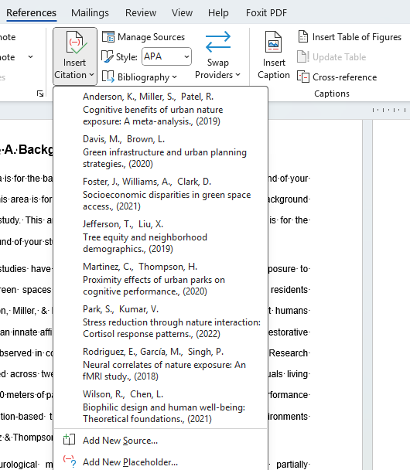
Figure 1 This is an example figure. Please use the built-in functionality of Microsoft Word. You can click on “Manage Sources” to add the citation you want. Then you can select a citation under the menu of “Insert Citation”.

Adding Figure Caption
Like adding references, if you are going to add a new figure, please use the functionality provided by Microsoft Word. In the same tab as references, you can click a button named “Insert Caption” to add the caption under a figure. Then this figure can be included in the table of figures.
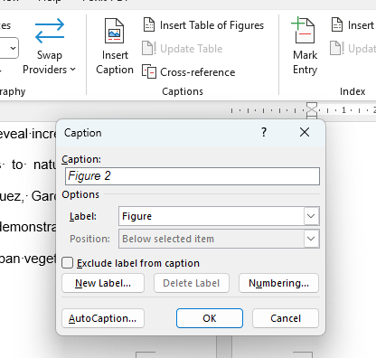
Figure 2 This is an example figure. By using this button, the software can detect the figure caption and put it in the table of figures.

Significance
This area is for the significance of your study. This area is for the significance of your study. This area is for the significance of your study. This area is for the significance of your study. This area is for the significance of your study.
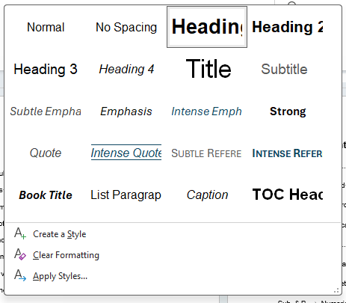
Figure 3 This is a testing figure. You can choose the style of your selected text. In which, you can specify whether the text is a normal text, a section title (Heading 1) or and subsection title (Heading 2).
The antique bookstore smelled of vanilla and forgotten stories. Between the towering shelves, dust motes danced like tiny galaxies in shafts of amber sunlight. Oliver ran his fingers along the worn spines, each one a doorway to someone else's imagination. A leather-bound journal caught his attention, its pages yellow with age and filled with faded ink sketches of mechanical contraptions that belonged to no era he recognized.
The shopkeeper, a woman with silver hair braided with colorful ribbons, hummed an unfamiliar melody while arranging crystals on the counter. Her cat, a magnificent orange tabby named Fibonacci, watched the proceedings with the dignified air of someone who understood far more than they let on.
Thunder rumbled in the distance, promising an afternoon storm. The wind chimes hanging from the porch began their metallic conversation, warning of rain to come. Oliver closed the mysterious journal and tucked it under his arm, knowing somehow that today would be different from all the days before. The brass bell above the door sang a farewell note as he stepped back into the world, where puddles were already beginning to form in the cobblestone streets.
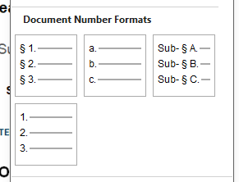
Figure 4 This is another figure. The numbering of sections and subsections are defined in this template.

Objectives
The old lighthouse keeper had developed quite a collection of unusual items over his forty years of service. Each piece told a story of storms weathered and ships guided safely to harbor:
- His most prized possessions included a compass that always pointed toward the nearest cup of coffee, a collection of sea glass arranged by color and opacity, three different types of fog horns that each produced distinctly melancholy sounds, a weathered logbook filled with observations about migrating whales, an assortment of message bottles that had washed ashore over the decades, and a telescope that supposedly belonged to a famous pirate captain.
- Local fishermen often brought him new additions to his collection, understanding that the lighthouse keeper served as an unofficial curator of maritime mysteries. His small cottage had become a repository of oceanic oddities, each item carefully catalogued and lovingly maintained. The walls themselves seemed to breathe with the salt air and whispered tales of adventure.
- On particularly quiet nights, when the beam swept across calm waters and the only sounds were waves lapping against the rocky shore, he would examine these treasures by lamplight. The compass would spin lazily in circles, confused by the absence of caffeine nearby. The sea glass caught and scattered the warm glow like tiny stained glass windows.

Methods and Materials

Theoretical Framework
The old lighthouse keeper adjusted his weathered cap as the morning fog began to lift from the harbor. Seagulls circled overhead, their cries mixing with the distant sound of fishing boats returning with their dawn catch. Margaret had lived in this coastal town for thirty-seven years, yet she still found herself pausing each morning to watch the rhythmic dance of waves against the rocky shore.

Numerical Simulations
Down at the marina, Carlos was already preparing his small café for the breakfast rush. The smell of fresh coffee and cinnamon rolls would soon draw the early risers and weekend tourists who wandered through the narrow cobblestone streets. His grandmother's recipe for blueberry scones had become legendary among the locals, though he never revealed the secret ingredient that made them so irresistible.

Experimental Setup
The antique bookstore on Maple Street held thousands of stories within its cramped shelves. Dust motes floated through streams of sunlight that filtered through the tall windows, creating an almost magical atmosphere. Mrs. Henderson, the owner, could often be found curled up in the reading corner with a mystery novel and a cup of chamomile tea, completely absorbed in worlds far from her quiet shop.

Data Analysis
Meanwhile, the old clock tower chimed nine times, echoing across the town square where pigeons pecked at breadcrumbs scattered by children on their way to school.
The midnight train pulled into the station with a mechanical sigh, its yellow headlights cutting through the autumn drizzle. Thomas clutched his leather satchel tighter, wondering if he'd made the right decision to leave everything behind. The platform was nearly empty except for a woman in a red coat reading a newspaper under the flickering lamppost.
Table 1 This is an example table of data.
Region | Q1 Sales ($000) | Q2 Sales ($000) | Q3 Sales ($000) | Q4 Sales ($000) | Product Category | Sales Rep
Northeast | 247 | 312 | 289 | 405 | Electronics | Sarah Chen
Southwest | 156 | 198 | 234 | 298 | Home & Garden | Miguel Rodriguez
Pacific | 389 | 423 | 367 | 512 | Automotive | Jessica Park
Southeast | 203 | 187 | 256 | 334 | Clothing | David Thompson
Midwest | 298 | 341 | 278 | 389 | Sports Equipment | Amanda Foster

Results

Result #1
In the distance, the city skyline glowed with a thousand office windows, each one representing someone working late into the night. Pizza delivery drivers weaved through traffic on their motorcycles, carrying hope and sustenance to those burning the midnight oil. The radio in apartment 4B played jazz music softly, its melancholy notes drifting down to the street below.

Result #2
A stray cat with one white paw picked its way carefully across the wet pavement, pausing to investigate a discarded sandwich wrapper. The corner deli's neon sign buzzed intermittently, casting pink and blue shadows on the brick wall where someone had painted a mural of soaring birds.

Result #3
Professor Williams sat in her study, surrounded by towers of research papers and half-empty coffee cups. Her latest archaeological discovery had the potential to rewrite history, but she needed three more weeks to verify her findings. The grandfather clock in the hallway ticked steadily, marking the passage of time with relentless precision.
Outside her window, snow began to fall for the first time that winter.

Discussion

Comparing Existing Works in the Literature
The abandoned carousel in Riverside Park creaked gently in the evening breeze, its painted horses frozen mid-gallop. Elena discovered it while taking a shortcut home from the library, their vibrant colors now faded but still beautiful against the overgrown weeds. She imagined the laughter of children from decades past echoing through the empty fairground.

Implications of the Work
At the hardware store downtown, Mr. Peterson was cataloging his inventory of peculiar items that customers rarely requested anymore: wooden dowels, brass hinges from the 1950s, and mysterious tools whose purposes had been forgotten. His grandson Jake preferred working with computers, but he secretly loved the musty smell of the old store and the stories each rusty contraption could tell.

Limitations
The community garden behind the elementary school buzzed with activity every Saturday morning. Volunteers of all ages tended to tomato plants, herb patches, and sunflowers that towered above the chain-link fence. Mrs. Rodriguez always brought homemade lemonade in a large glass pitcher, and the children competed to see who could spot the most butterflies among the marigolds.

Future Directions
A food truck painted bright orange served Korean tacos at the corner of Fifth and Main, drawing long lines of office workers during lunch hour. The owner, Jin, had immigrated three years ago with nothing but his grandmother's kimchi recipe and an unshakeable belief that fusion cuisine would find its audience in this sleepy Midwestern town.

References
Anderson, K., Miller, S., & Patel, R. (2019). Cognitive benefits of urban nature exposure: A meta-analysis. Journal of Environmental Psychology, 67, 112-125.
Davis, M., & Brown, L. (2020). Green infrastructure and urban planning strategies. Urban Studies Quarterly, 45(3), 78-94.
Foster, J., Williams, A., & Clark, D. (2021). Socioeconomic disparities in green space access. Social Science & Medicine, 289, 114-128.
Jefferson, T., & Liu, X. (2019). Tree equity and neighborhood demographics. Landscape and Urban Planning, 182, 45-58.
Martinez, C., & Thompson, H. (2020). Proximity effects of urban parks on cognitive performance. Environmental Research, 188, 109-117.
Park, S., & Kumar, V. (2022). Stress reduction through nature interaction: Cortisol response patterns. Psychoneuroendocrinology, 138, 105-188.
Rodriguez, E., García, M., & Singh, P. (2018). Neural correlates of nature exposure: An fMRI study. NeuroImage, 195, 267-279.
Wilson, R., & Chen, L. (2021). Biophilic design and human well-being: Theoretical foundations. . Architectural Science Review, 64(4), 298-312.

